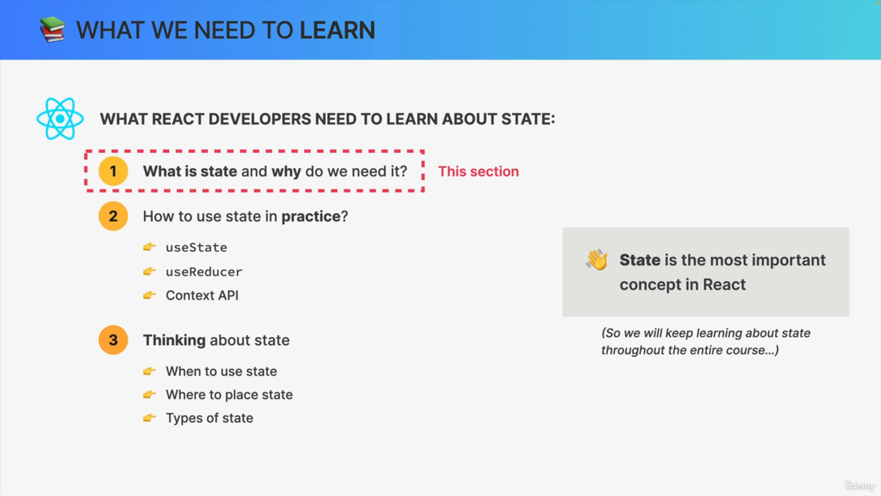

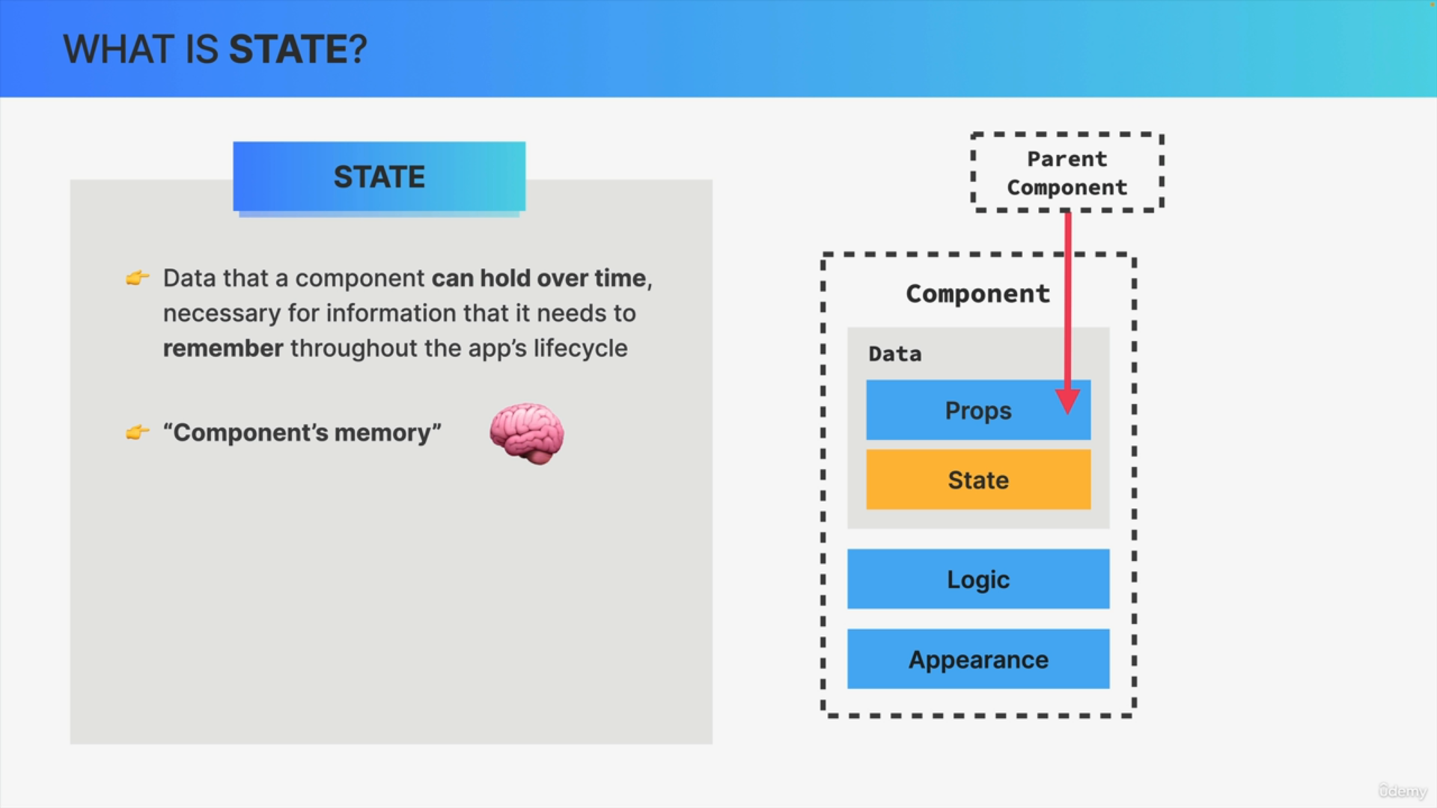

What if a component needs to actually hold its own data and also hold it over time? What if we actually want to make our app interactive changing the UI as a result of an action?

That's where state comes into play.

So, state is basically data that a component can hold over time and we use it for information that a component needs to remember throughout its lifecycle. Therefore, we can think of state as being the memory of a component.

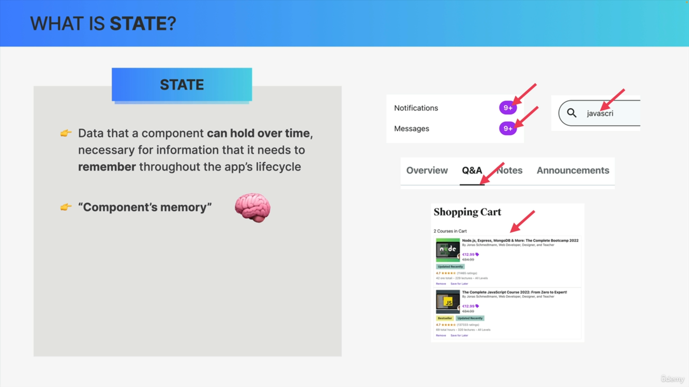

For example, like a notification count, the text content of an input field, or the active tab in a tab component. It can also be a bit more complex data, for example, the content of a shopping cart.

What all these pieces of state have in common is that in the application, the user can easily change these values. For example, when they read a notification, the count will go down by one, or when they click on another tab, that tab will become active. Therefore, each of these components needs to be able to hold this data over time i.e. over the lifecycle of the application.

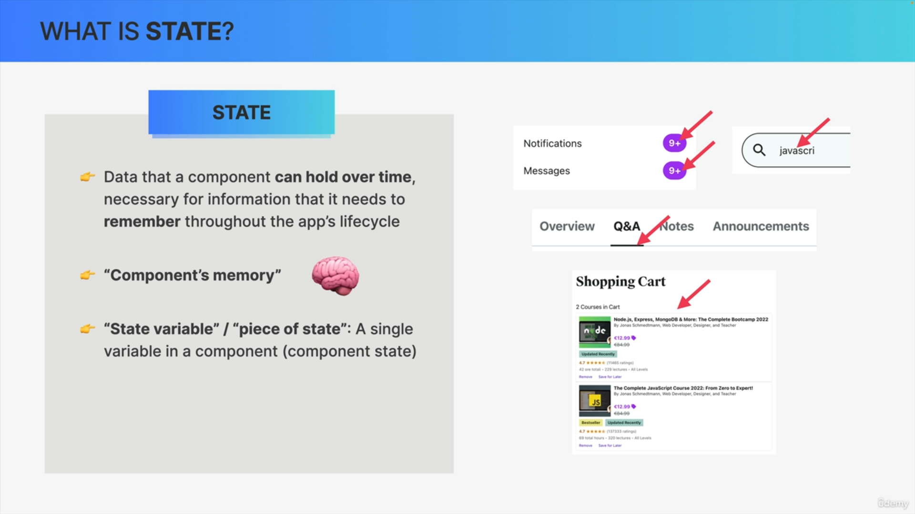

For that reason, each of these pieces of information is a piece of state.

So, a piece of state, or a state variable is just one single actual variable in the component that we can define in our code.

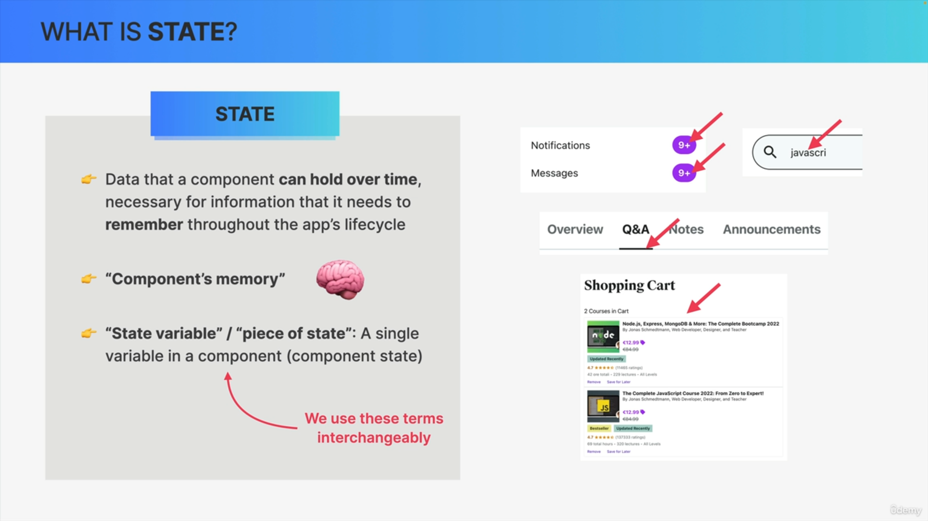

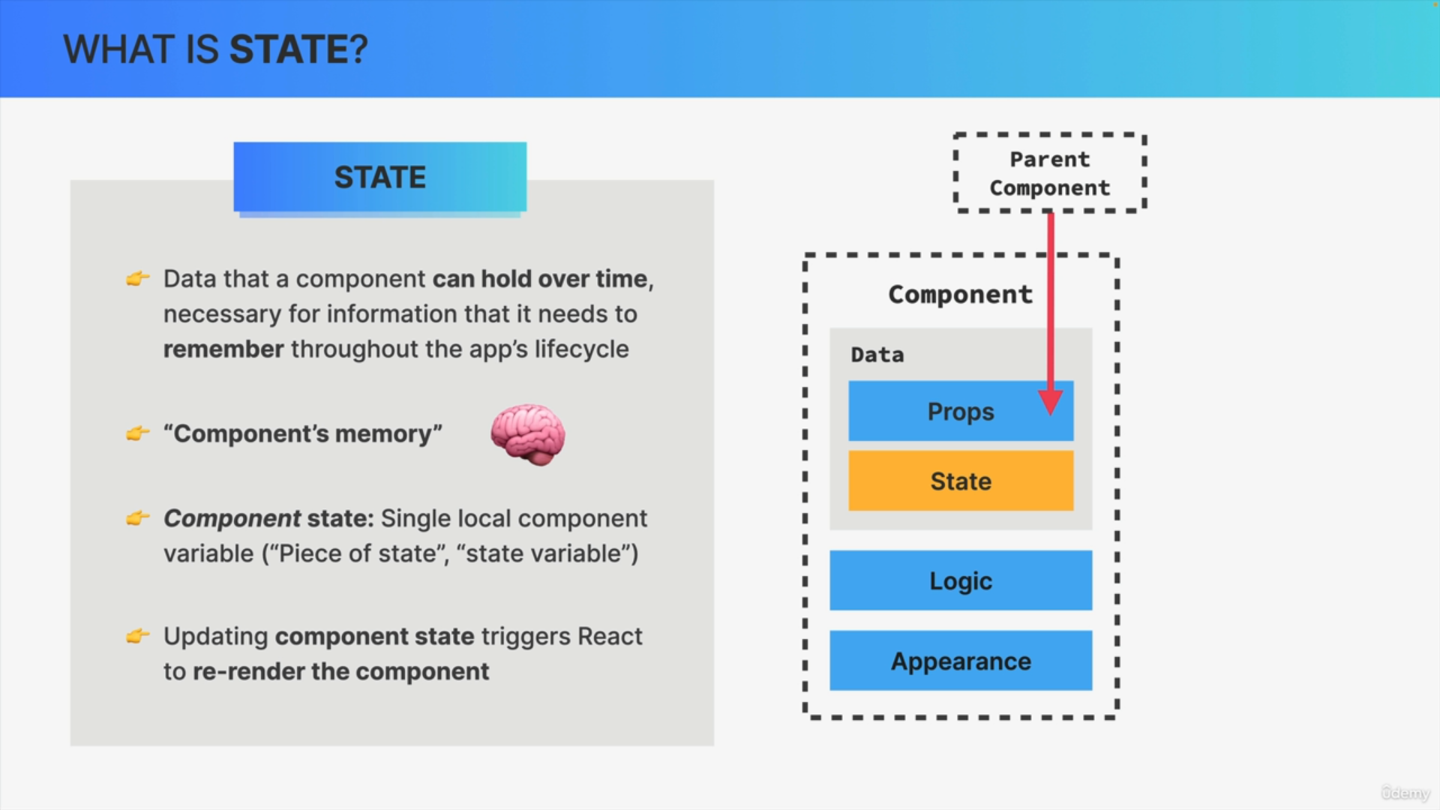

The most important aspect of state is the fact that updating state triggers React to re-render the component in the user interface.

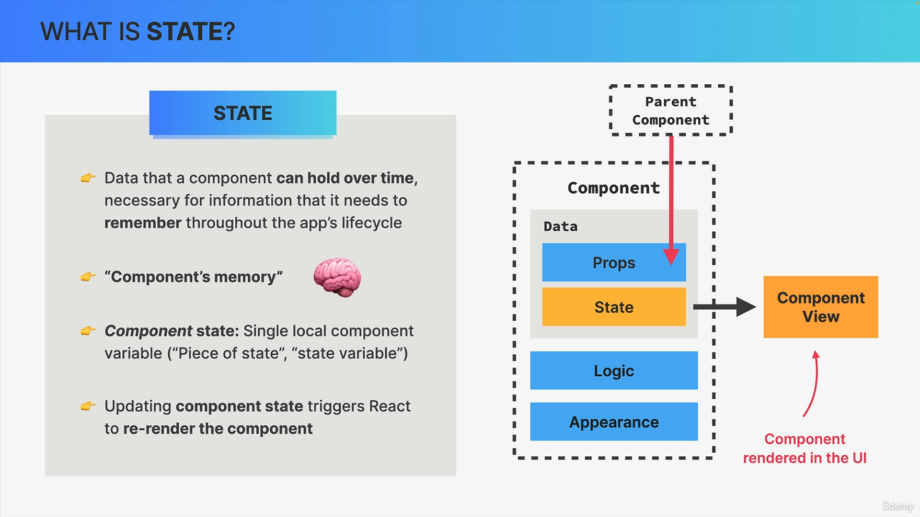

So, it will create a new updated view for that component. A component's view is basically just the component visually rendered on the user interface.

When one single component is rendered, we call that a view. So, all the views combined together then make up the final user interface.

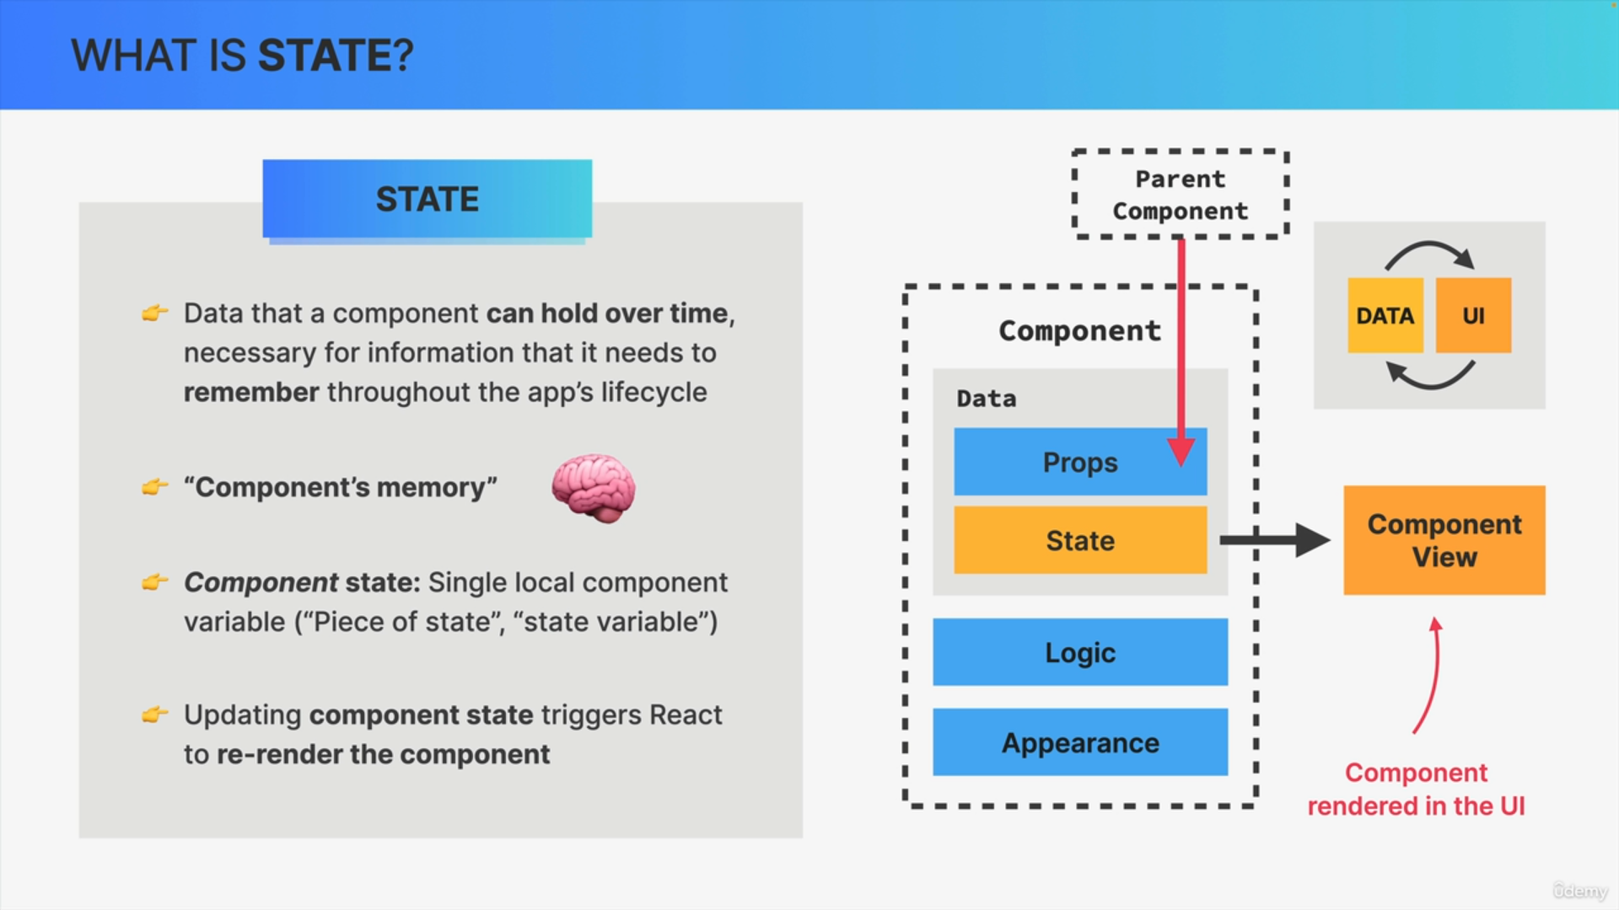

React automatically keeps data in sync with the UI. So, state is how React keeps the user interface in sync with data. We change the state, we change the UI.

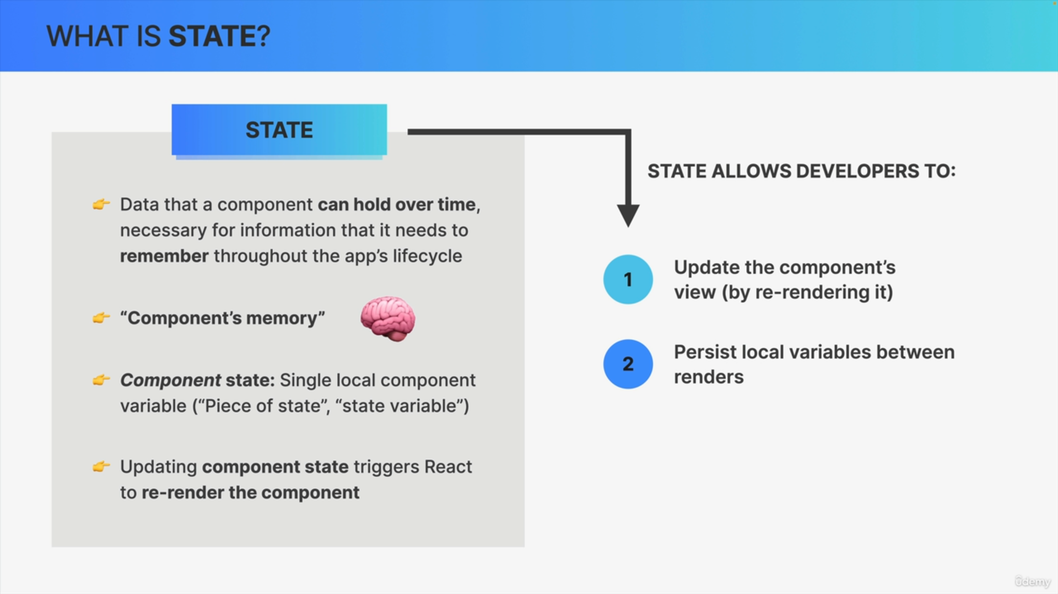

State allows developers to do two important things.

1. First, state allows us to update the component's view by re-rendering the component. So, it gives us a way to change part of the UI.
2. Second, state allows developers to persist local variables between multiple renders and re-renders.

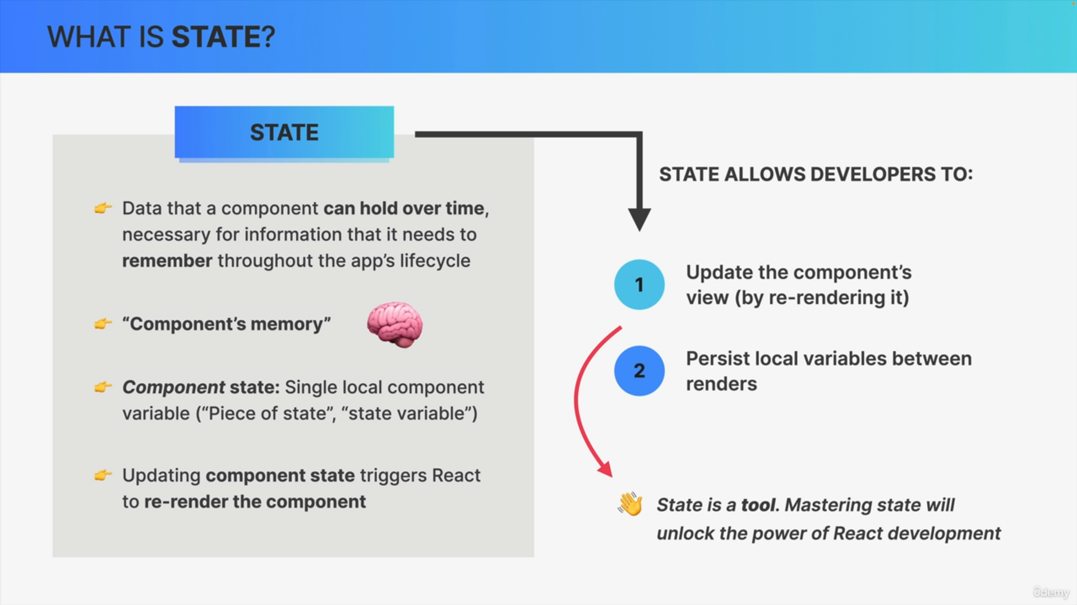

State is the most powerful tool that we have in the world of React. So, understanding how a state works, what it does and understanding the mechanics of state will unlock the power of React development for you.